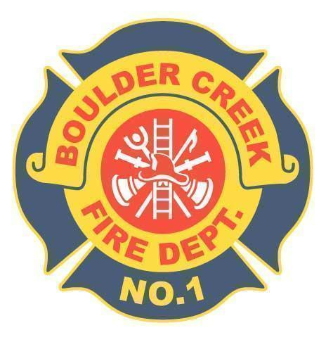

**BOULDER CREEK FIRE PROTECTION DISTRICT**

**13230 Central Avenue, Boulder Creek CA 95006 · Office: (831) 338-7222 · Fax: (831) 338-7226**

Board of Directors

Minutes of the Board of Directors Meeting

Regular Board Meeting

April 16th, 2024

1.0 Convene Meeting/Roll Call

* The Regular Board meeting of the Board of Directors of the Boulder Creek Fire Protection District was called to order by Chairman Locatelli on April 16th, 2024 at 9:00 A.M. Present were, Director Robustelli, Director Locatelli, Director Presswood, Director Currier, Director Scruggs, Fire Chief Bingham and Admin Aileigh McCormack. Three public members were present.

2.0 Additions and Deletions to Agenda

* Correspondence letter regarding sewer rate increase at Jameson Station

3.0 Oral Communications

* None

4.0 Approval of Minutes

.01 Regular Board Meeting March 12th, 2024

* Motion made by Dir. Presswood to approve the minutes from the Regular Meeting March 12th, 2024, seconded by Dir. Robustelli. Vote was unanimous. Motion carries.

5.0 Approval/Payment of Bills

.01 Approval/Payment of Bills and Review of Financials

* Chief Bigham pointed out that page numbers have now been added to the top of the completed Board Packets to help stay organized.
* Chief Bingham clarified page 7, CalCard payment to GoTo is an annual fee for remote IT Support.
* Dir. Robustelli asked about the custom picture frame and Chief Bingham explained that it was a commissioned piece that was started a couple years ago and it was customized to the Districts wants and requests.
* Chief Bingham explained the rental of the forklift was needed due to the taller box on the new ambulance, two fans were removed from the apparatus bay in order for it to fit.
* Motion made by Dir. Robustelli to approve the payment of bills in the amount of

$44,492.15, seconded by Dir. Currier. Vote was unanimous. Motion carries.

6.0 Correspondence

* Chief Bingham provided a letter regarding the sewage rates at Jameson Station and the proposed spike in rate as it could triple in cost. The board confirmed that CalFire was still responsible for the terms and conditions of the lease.

7.0 Unfinished Business

.01 NFIRS / First Due report

* Dir. Robustelli made a note to point out the Officers running more calls this month and their numbers are going up.
* Dir. Scruggs asked how often we look at the percentages to gather the quarterly numbers and when the next list will go out. Chief Bingham is going to check the timeline.

.02 Repair of the fire station kitchen

* Chief Bigham has called Bill Kempf and left a message but has yet to receive a response.
* The Directors advised Chief Bingham to move on from this contact and find someone else so the work can begin if Bill Kempf is to busy.

.03 Station generator replacement

* No report, still waiting for energy audit.

.04 Special District Associations (FDAC & CSDA)

* CSDA (California Special Districts Association) came to the office and gave a presentation and provided some packets for the Directors. They also would like to come to the May board meeting to present and answer questions.
* Education opportunities and membership costs are some of the main questions the Directors have.

.05 Report on the billing process between the County of Santa Cruz and US Bank

* After doing a 12 month search, there was a discrepancy between the amount asked to pay and the amount actually paid. The County took full responsibility and admitted it was on their end and paid the late fees that were billed to us due to the mistake.
* Moving forward, Chief Bingham and Admin will do quarterly reviews and ensure no finance charges are being levied.
* Dir. Robustelli asked that the quarterly check go in the board packets moving forward.

.06 Website compliance check

* For April 2024 the website scored 100% in ADA compliance.

.07 Apparatus replacement schedule committee

* Dir. Scruggs, Dir. Robustelli and Chief Bingham are the members in the committee.
* The next meeting is scheduled for April 29th at 2:00PM
* Dir. Robustelli asked that the May regular board meeting be moved to May 21st, due to his absence. This change was approved by the board.

.08 Budget committee

* Dir. Locatelli would like to schedule another meeting and will connect with Chief Bingham to solidify a date.

8.0 New Business

.01 Adjusted Budget Resolution 24-01 for FY 23/24

* Budget adjustment for the FY 23/24 budget, the changes are made on a few line items.
* Motion made by Dir. Robustelli to approve the Resolution 24-01 Adoption of Adjusted Budget for Fiscal Year 2023-2024, seconded by Dir. Currier. Vote was unanimous. Motion carries.

.02 Station siren / Public emergency warning system

* A draft of a flier was provided for the announcement of the siren test.
* The board discussed the draft content and timing of the siren testing.
* Dir. Robustelli suggested adding a note saying this test also falls on drill nights and is used to get firefighters down to the station for training.
* Directors would like the flier to be posted to the website, social media and newspapers.
* Chief Bingham to complete the draft flier and return it to the next meeting for approval.

9.0 Chief’s Report

Administration

* Attended a Stakeholders meeting with PG&E management and the BCBA regarding undergrounding power microgrids in the downtown business district of Boulder Creek
* Attended a presentation with California Special Districts Association
* County EMSIA
* County Chiefs Association
* County Operations
* NetCom Task policy review on strike team / task force deployment
* 2024 BCFPD High School Fire Internship week 15 current subject wildland
* BCFD / SCCFCA Hosted the annual Chiefs’ feed on 3/28/24
* BCFD hosted blood drive w/ Red Cross 3/27/24
* Chief Bingham assumed the (OAC) Operational Area Coordinator role for the month of April
* BCFD hosted IROC (Statewide resource ordering) class March 18 & 19

Chief Bingham is now a certified IROC administrator.

* We have received two letters of interest for the upcoming Captains test. (period for application now closed)
* Scheduled a couple business inspections 1. Camp Harmon 2. Liberty Bank for the month of April

Operations

* Chief Bingham instructed on intro to wildland firefighting for the County Fire Academy
* Chief Bingham responded to Scotts Valley Fire District for a structure fire with fatality as investigation team member.
* Continuing the in-service of new 2166 (radio and sticker/lettering in progress) Still waiting on a new gurney
* BCFD hosted crab feed fundraiser on 3/23
* Several more knox products were installed per fire code requirements
* Camp Harmon annual inspection completed while also drafting a pre plan for response

Maintenance

* E-2120 was safety checked and cleaned up along with a road and pump test
* U-2192 battery issue diagnosed and repaired
* Vehicle inventories and mechanicals completed
* Landscape maintenance behind Sheriff’s substation
* E2137 repaired foam tank and reinstalled
* Calibration of atmospheric monitors for each unit
* Leaf blew back parking lot and wash windows
* Vacuumed the training room and general clean up of training room
* Fuel delivery received

10.0 Adjournment at 10:58AM